**1.Problem Statement:**

Predict the Chronic kidney disease(CKD) based on the given dataset & create a best machine learning classification module.

**2.Basic info about the dataset:**

**Coulumns : 25**

**Rows : 399**

**3.Dataset pre-processiong method:**

AI algorithm doesn’t work for catagorical value .so the given input had a catagorical value,from the input catagorical value is nominal data.String converted into number followed by **one hot encoding method**.

**4.To find the best machine learning classification module based on evalumetrics value:**

**1)Random forest:**

**I) REPORT:**

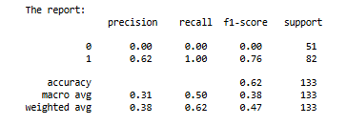

**II) ROC_AUC_SCORE : 0.999**

**2)DECISION TREE:**

**I)REPORT:**

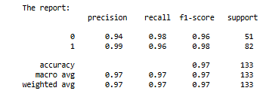

**II) ROC_AUC_SCORE : 0.9719**

**3)SVM :**

**I)REPORT:**

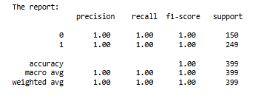

**II) ROC_AUC_SCORE : 1.0**

**4)NAVIE BAYE’S:**

**1)GAUSSIAN NB:**

**I)REPORT:**

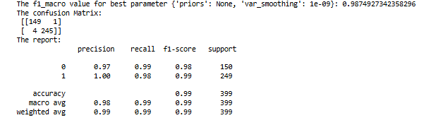

**II) ROC_AUC_SCORE : 0.99**

**2) CategoricalNB:**

**I)REPORT:**

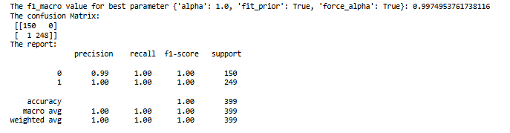

**II) ROC_AUC_SCORE : 0.999**

**3)** **MultinomialNB:**

**I)REPORT:**

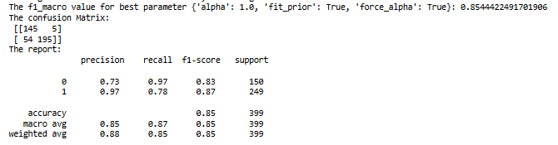

**II) ROC_AUC_SCORE : 0.9499**

**4)** **BernoulliNB:**

**I)REPORT:**

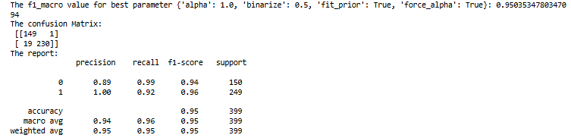

**II) ROC_AUC_SCORE : 0.9948**

**5)** **ComplementNB:**

**I)REPORT:**

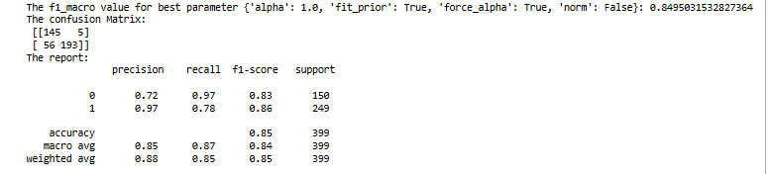

**II) ROC_AUC_SCORE : 0.9499**

**5)KNN:**

**I)REPORT:**

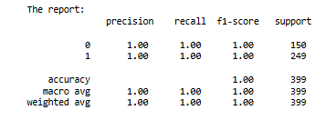

**II) ROC_AUC_SCORE : 1.0**

**6).LOGISTIC GRID:**

**I)REPORT:**

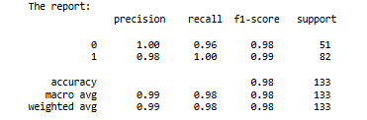

**II) ROC_AUC_SCORE : 0.999**

**5.Best ML Classification module for given problem statement:**

**SVC & KNN** both are good performance algorithm based on accuracy(i.e 1).

i)based on confusion matrics both modle are correctly classified each classes.